The Twenty-first Sunday after Pentecost
October 18, 2026
Holy Eucharist

​St. Mary's Episcopal Church
165 Ponquogue Ave.
Hampton Bays, NY 11946

​

Reminder: Only for Sunday, Nov. 1
Change in Service time for ABATE
10am instead of 9am.

Clergy
The Rev. Justin Falciani, Rector
fr.jfalciani@gmail.com

Fr. Eliot Frederic, Retired Priest in Residence

St. Mary’s Church
Phone: 631-728-0776
(Office Hours: Tue, Thurs., Sat. 9am-12noon)
Email: office@stmaryshb.org
Website: http://www.stmaryshb.org/

Sundays:
9am, Holy Eucharist
7:00 pm, Holy Eucharist (Spanish)
Saturday Vigil 5:30pm
Holy Eucharist

Wednesday 9am
Holy Eucharist & Anointing

Holy Days as announced

Wardens
Adrian Drake (26), Karen Lucas (27)

Vestry Members
Elaine Curry (26), Irene Blydenburgh (26),
Fred Coulton (27), Paula Godfrey (27),
John Mitchell (28), Kevin Sullivan (28)

Treasurer
Janet Hanks

Director of Music
Jim Tartaglia

Christian Education
Julia Distenfeld, Adrian Drake,
Karen Lucas

Parish Administrator
Jennifer Estrada

Copyright music printed in this bulletin is used with permission by One License: code A-742929
Additional events and ministry activities will be posted on our Website and Facebook Page

Processional Hymnal No. 525 (verses 1-3)
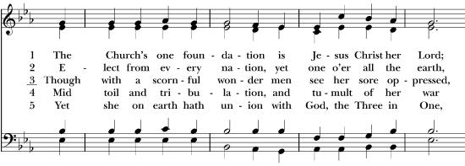
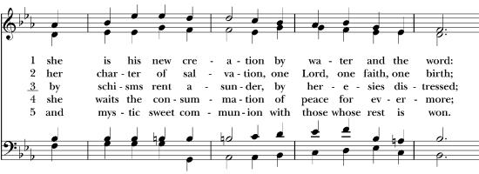
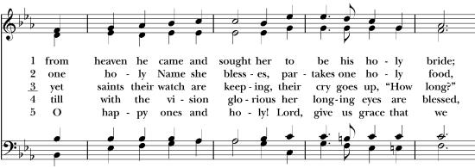
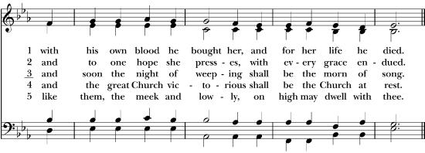

Celebrant | Blessed be God: Father, Son, and Holy Spirit.
People | And blessed be his kingdom, now and forever. Amen.

The Priest says
Almighty God, to you all hearts are open, all desires known, and from you no secrets are hid: Cleanse the thoughts of our hearts by the inspiration of your Holy Spirit, that we may perfectly love you, and worthily magnify your holy Name; through Christ our Lord. Amen.

Song of Praise Hymnal S35 Venite
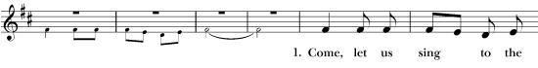
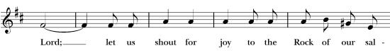
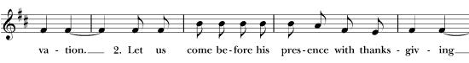
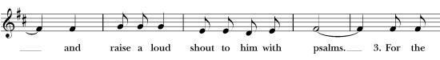
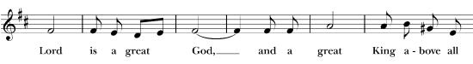
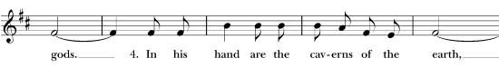
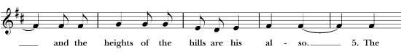
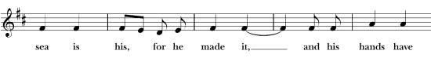
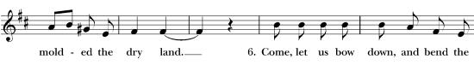
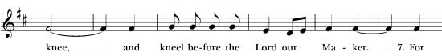
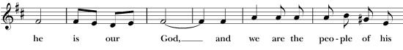
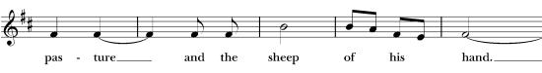

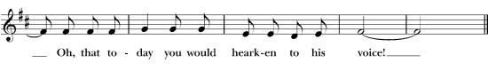

Collect of the Day
The Celebrant says to the people
The Lord be with you.
People And also with you.
Celebrant Let us pray.

Almighty and everlasting God, in Christ you have revealed your glory among the nations: Preserve the works of your mercy, that your Church throughout the world may persevere with steadfast faith in the confession of your Name; through Jesus Christ our Lord, who lives and reigns with you and the Holy Spirit, one God, for ever and ever. Amen.

First Reading Exodus 33:12-23

Reader: A Reading from the Book of Exodus.
Moses said to the Lord, “See, you have said to me, ‘Bring up this people’; but you have not let me know whom you will send with me. Yet you have said, ‘I know you by name, and you have also found favor in my sight.’ Now if I have found favor in your sight, show me your ways, so that I may know you and find favor in your sight. Consider too that this nation is your people.” He said, “My presence will go with you, and I will give you rest.” And he said to him, “If your presence will not go, do not carry us up from here. For how shall it be known that I have found favor in your sight, I and your people, unless you go with us? In this way, we shall be distinct, I and your people, from every people on the face of the earth.”
The Lord said to Moses, “I will do the very thing that you have asked; for you have found favor in my sight, and I know you by name.” Moses said, “Show me your glory, I pray.” And he said, “I will make all my goodness pass before you, and will proclaim before you the name, ‘The Lord’; and I will be gracious to whom I will be gracious, and will show mercy on whom I will show mercy. But,” he said, “you cannot see my face; for no one shall see me and live.” And the Lord continued, “See, there is a place by me where you shall stand on the rock; and while my glory passes by I will put you in a cleft of the rock, and I will cover you with my hand until I have passed by; then I will take away my hand, and you shall see my back; but my face shall not be seen.”
Reader: The Word of the Lord. People: Thanks be to God.

Psalm 99

Reader: Let us read Psalm 99 as found in the bulletin, responsively, beginning at half verse.
1 The Lord is King;
let the people tremble; *
he is enthroned upon the cherubim;
let the earth shake.
2 The Lord is great in Zion; *
he is high above all peoples.
3 Let them confess his Name, which is great and awesome; *
he is the Holy One.
4 "O mighty King, lover of justice,
you have established equity; *
you have executed justice and righteousness in Jacob."
5 Proclaim the greatness of the Lord our God
and fall down before his footstool; *
he is the Holy One.
6 Moses and Aaron among his priests,
and Samuel among those who call upon his Name, *
they called upon the Lord, and he answered them.
7 He spoke to them out of the pillar of cloud; *
they kept his testimonies and the decree that he gave them.
8 O Lord our God, you answered them indeed; *
you were a God who forgave them,
yet punished them for their evil deeds.
9 Proclaim the greatness of the Lord our God
and worship him upon his holy hill; *
for the Lord our God is the Holy One.

Second Reading 1 Thessalonians 1:1-10

Reader: A Reading from Saint Paul’s First letter to the Thessalonians.
Paul, Silvanus, and Timothy, To the church of the Thessalonians in God the Father and the Lord Jesus Christ:
Grace to you and peace.
We always give thanks to God for all of you and mention you in our prayers, constantly remembering before our God and Father your work of faith and labor of love and steadfastness of hope in our Lord Jesus Christ. For we know, brothers and sisters beloved by God, that he has chosen you, because our message of the gospel came to you not in word only, but also in power and in the Holy Spirit and with full conviction; just as you know what kind of persons we proved to be among you for your sake. And you became imitators of us and of the Lord, for in spite of persecution you received the word with joy inspired by the Holy Spirit, so that you became an example to all the believers in Macedonia and in Achaia. For the word of the Lord has sounded forth from you not only in Macedonia and Achaia, but in every place your faith in God has become known, so that we have no need to speak about it. For the people of those regions report about us what kind of welcome we had among you, and how you turned to God from idols, to serve a living and true God, and to wait for his Son from heaven, whom he raised from the dead-- Jesus, who rescues us from the wrath that is coming.
Reader: The Word of the Lord. People: Thanks be to God.

Gradual Hymnal No. 495

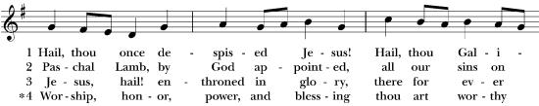
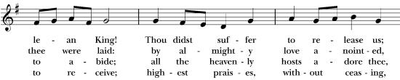
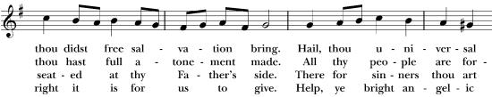
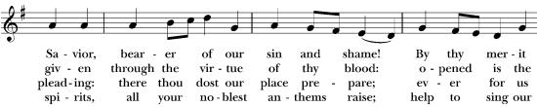

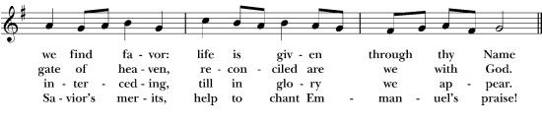

Holy Gospel Matthew 22:15-22 (All stand)

Priest: The Holy Gospel of Our Lord Jesus Christ According to Saint Matthew.

People: Glory to you, Lord Christ.

The Pharisees went and plotted to entrap Jesus in what he said. So they sent their disciples to him, along with the Herodians, saying, “Teacher, we know that you are sincere, and teach the way of God in accordance with truth, and show deference to no one; for you do not regard people with partiality. Tell us, then, what you think. Is it lawful to pay taxes to the emperor, or not?” But Jesus, aware of their malice, said, “Why are you putting me to the test, you hypocrites? Show me the coin used for the tax.” And they brought him a denarius. Then he said to them, “Whose head is this, and whose title?” They answered, “The emperor’s.” Then he said to them, “Give therefore to the emperor the things that are the emperor’s, and to God the things that are God’s.” When they heard this, they were amazed; and they left him and went away.

Priest: The Gospel of the Lord. People: Praise to you, Lord Christ.
Sermon Mother Lilo Carr Rivera
The Nicene Creed
We believe in one God, the Father, the Almighty,
maker of heaven and earth, of all that is, seen and unseen.
We believe in one Lord, Jesus Christ, the only Son of God,
eternally begotten of the Father, God from God, Light from Light, true God from true God, begotten, not made, of one Being with the Father.
Through him all things were made, For us and for our salvation
he came down from heaven: by the power of the Holy Spirit he became incarnate from the Virgin Mary, and was made man.
For our sake he was crucified under Pontius Pilate; he suffered death and was buried.
On the third day he rose again in accordance with the Scriptures;
he ascended into heaven and is seated at the right hand of the Father.
He will come again in glory to judge the living and the dead,
and his kingdom will have no end.
We believe in the Holy Spirit, the Lord, the giver of life,
who proceeds from the Father and the Son.
With the Father and the Son he is worshiped and glorified.
He has spoken through the Prophets.
We believe in one holy catholic and apostolic Church.
We acknowledge one baptism for the forgiveness of sins.
We look for the resurrection of the dead, and the life of the world to come. Amen

Prayers of the People
Leader: Let us pray for the Church, the world, and all those in need, remembering the words of Jesus to give to God the things that are God’s. Let us offer our prayers to God, whose image is reflected in every human being.
Leader: For the Church throughout the world, especially for Sean our Presiding Bishop, Adam our Bishop, Geralyn Assisting Bishop, Justin our Rector, and Eliot Assisting Priest; That we with them may faithfully proclaim the Gospel, serve with humility, and give to God our hearts, our gifts, and our lives. Lord, in your mercy,
People: Hear our prayer.
For the leaders of nations and all who hold positions of authority, especially: Donald our President, Kathy our Governor, that they may govern with wisdom, integrity, and a commitment to the common good. Guide them to seek peace, uphold justice, and protect the dignity of every person. Lord, in your mercy,
Hear our prayer.
For our communities and our neighbors, that we may recognize the image of God in every person, regardless of background, nationality, or circumstance. Teach us to overcome division, prejudice, and indifference, and to treat one another with love and respect. Lord, in your mercy,
Hear our prayer.
For all who struggle with poverty, hunger, homelessness, or injustice, that they may find comfort, support, and opportunities for a better life. Make us generous stewards of the blessings entrusted to us, ready to share what we have with those in need. Lord, in your mercy,
Hear our prayer.
For those who are sick, lonely, grieving, or burdened by worry, especially those on our Parish Prayer List: Wallace, Skye, Joe, Baby John, Harper, Heather, Raymond, Ryan and Patricia. You are invited to offer your own names, silently or aloud. (Pause for petitions.) Surround them with your healing presence, strengthen their faith, and give them peace. Lord, in your mercy,
Hear our prayer.
For Saint Mary’s Episcopal Church, Hampton Bays. that we may faithfully serve our neighbors and welcome all who seek a place of belonging. Help us to give not only our offerings, but also our time, talents, and love, reflecting Christ in all that we do. Lord, in your mercy,
Hear our prayer.
For those who have died +, especially those dear to us. You are invited to offer names either silently or aloud. (Pause for petitions). We pray that they may rest in your eternal peace. Comfort all who mourn and strengthen us in the hope of the resurrection. Lord, in your mercy,
Hear our prayer.
Leader: Gracious God, you have made us in your image and called us to give ourselves to your service. Receive these prayers and teach us to live faithfully in the world, offering to you all that we are and all that we have, through Jesus Christ our Lord. Amen.
Confession of Sin
Celebrant says
Let us confess our sins against God and our neighbor.
Silence may be kept.

Minister and People
Most merciful God, we confess that we have sinned against you
in thought, word, and deed, by what we have done,
and by what we have left undone. We have not loved you with our whole heart; we have not loved our neighbors as ourselves.
We are truly sorry and we humbly repent.
For the sake of your Son Jesus Christ, have mercy on us and forgive us;
that we may delight in your will, and walk in your ways,
to the glory of your Name. Amen.

Celebrant: Almighty God have mercy on you, forgive you all your sins through our Lord Jesus Christ, strengthen you in all goodness, and by the power of the Holy Spirit keep you in eternal life. Amen.

The Exchange of Peace
Priest: The peace of the Lord be always with you.
People: And also with you.
Priest: Let us offer each other a sign of Christ’s peace

Announcements and Blessings

Offertory: Anthem sung by choir

Doxology Old 100th
Praise God from whom all blessings flow; praise him, all creatures here below; praise him above, ye heavenly host: praise Father, Son, and Holy Ghost.

The Eucharistic Prayer 2 (EOW 1)

 | The Lord be with you.
People | And also with you.
Celebrant | Lift up your hearts.
People | We lift them to the Lord.
Celebrant | Let us give thanks to the Lord our God.
People | It is right to give our thanks and praise.
Celebrant
We praise you and we bless you, holy and gracious God,
source of life abundant. From before time you made ready the creation.
Your Spirit moved over the deep and brought all things into being:
sun, moon, and stars; earth, winds, and waters; and every living thing.

You made us in your image, and taught us to walk in your ways.
But we rebelled against you, and wandered far away; and yet, as a mother cares for her children, you would not forget us.
Time and again you called us to live in the fullness of your love.

And so this day we join with Saints and Angels in the chorus of praise that rings through eternity, lifting our voices to magnify you as we sing:

Sanctus Hymnal S-130, Holy, Holy, Holy*** 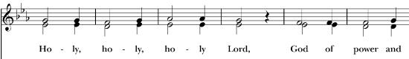 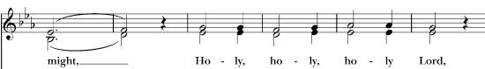 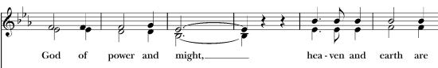 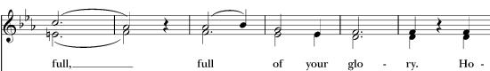 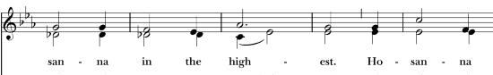 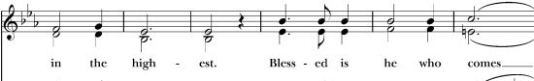 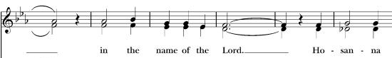 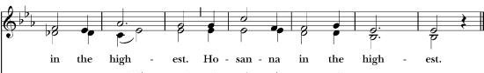
The Celebrant continues

Glory and honor and praise to you, holy and living God. To deliver us from the power of sin and death and to reveal the riches of your grace, you looked with favor upon Mary, your willing servant, that she might conceive and bear a son, Jesus the holy child of God.

Living among us, Jesus loved us. He broke bread with outcasts and sinners, healed the sick, and proclaimed good news to the poor. He yearned to draw all the world to himself yet we were heedless of his call to walk in love.
Then, the time came for him to complete upon the cross the sacrifice of his life, and to be glorified by you.*

On the night before he died for us, Jesus was at table with his friends.
He took bread, gave thanks to you, broke it, and gave it to them, and said:
“Take, eat: This is my Body, which is given for you. Do this for the remembrance of me.”***

As supper was ending, Jesus took the cup of wine. Again, he gave thanks to you, gave it to them, and said: “Drink this, all of you: This is my Blood of the new Covenant, which is poured out for you and for all for the forgiveness of sins. Whenever you drink it, do this for the remembrance of me.”***

Now gathered at your table, O God of all creation, and remembering Christ, crucified and risen, who was and is and is to come, we offer to you our gifts of bread and wine, and ourselves, a living sacrifice.

Pour out your Spirit upon these gifts that they may be the Body and Blood of Christ. Breathe your Spirit over the whole earth and make us your new creation, the Body of Christ given for the world you have made.
In the fullness of time bring us, with all your saints, from every tribe and language and people and nation, to feast at the banquet prepared from the foundation of the world.

Through Christ and with Christ and in Christ, in the unity of the Holy Spirit, to you be honor, glory, and praise, for ever and ever. AMEN.*

And now, as our Savior Christ has taught us, we sing,
The Lord’s Prayer (Blue Praise Book, page 123)

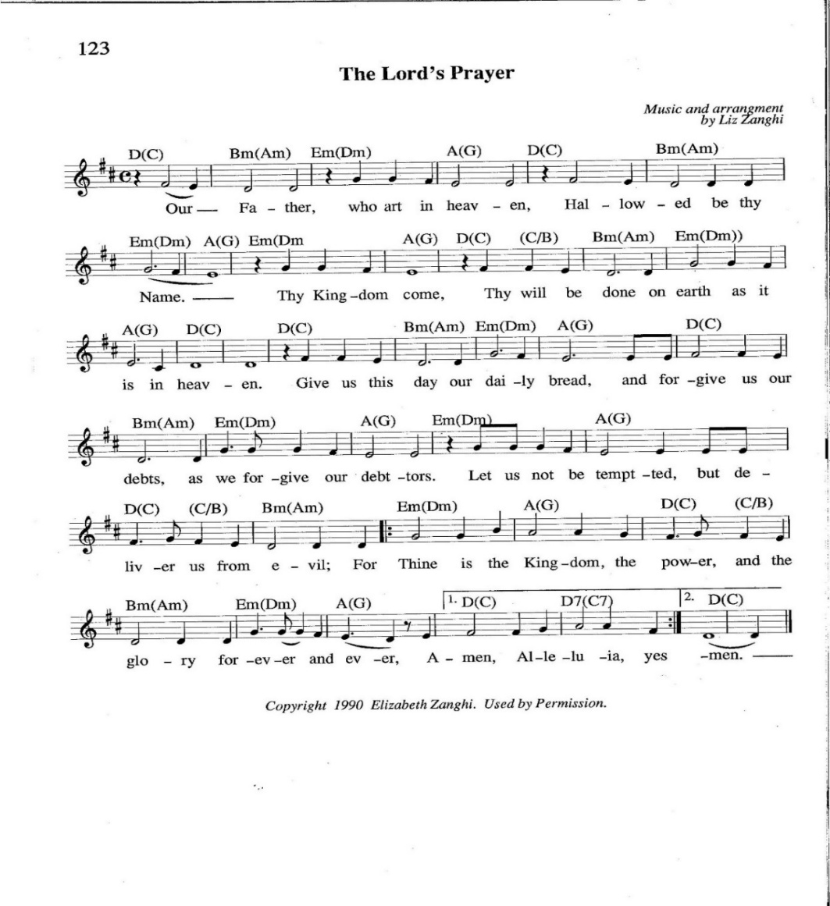

Angus Dei Hymnal S-163

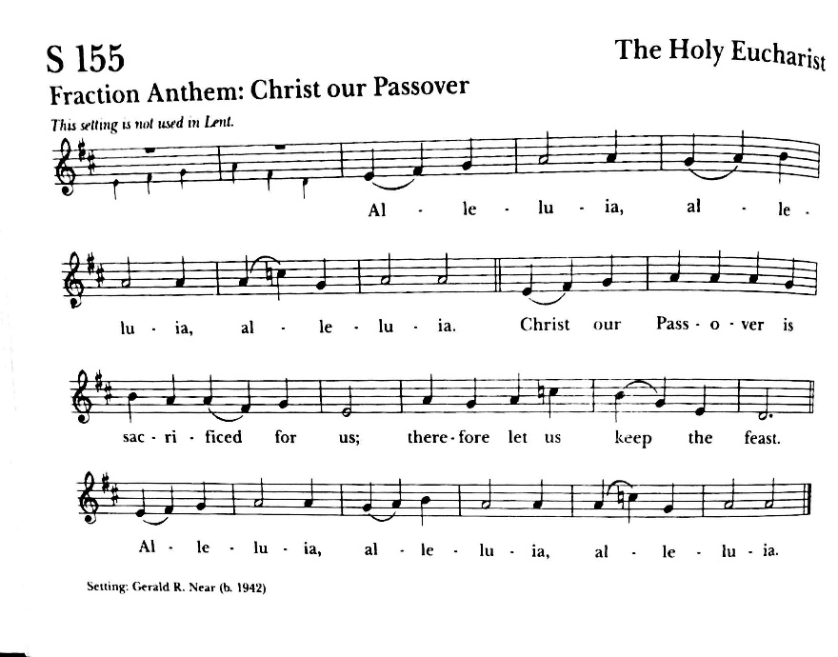
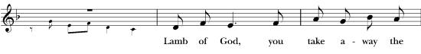
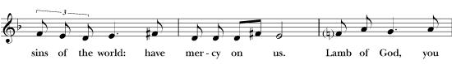
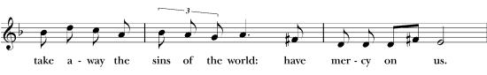
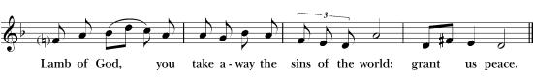
Communion Hymnal No. 341
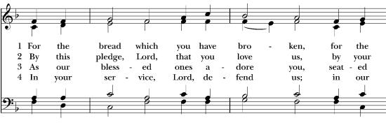
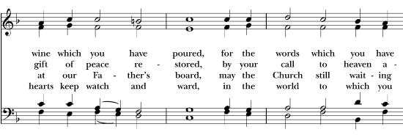

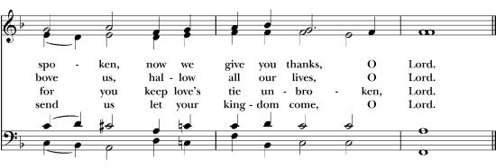

Post Communion Prayer Priest and People:

Almighty and everliving God, we thank you for feeding us with the spiritual food of the most precious Body and Blood of your Son our Savior Jesus Christ; and for assuring us in these holy mysteries that we are living members of the Body of your Son, and heirs of your eternal kingdom. And now, Father, send us out to do the work you have given us
to do, to love and serve you as faithful witnesses of Christ our Lord. To him, to you, and to the Holy Spirit, be honor and glory, now and for ever. Amen.

Dismissal and Blessing

Recessional Hymnal 427
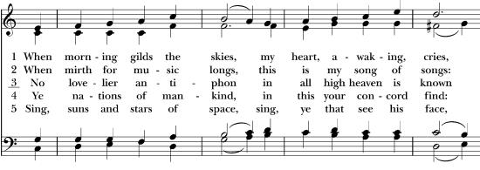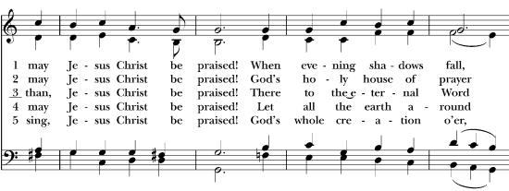
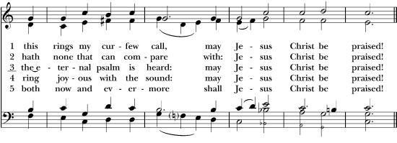
Vestry Meetings
Vestry meetings are held on the second Tuesday of every month.
Daughters of The King
Monthly meetings take place the 1st Tuesday of every month at 10:00am in the Fireside Room.

Did you know?
For those of us “of a certain age” who are now having to take our RMD’s (Required
Minimum Distributions) from our retirement accounts, it might be to your advantage to
use those funds to support St. Mary’s rather than writing a check from your regular
checking account. Simply put, a Qualified Charitable Donation reduces your taxable
income for the year. Since the funds MUST come directly from your retirement account,
please consult your financial advisor or your accountant for more information. Or, if you
prefer, see Janet Hanks, Russell Rose or Kevin Sullivan who all have tax experience
and could explain how this might work for you.
Emergency Winter Shelter for the Unhoused

Get Involved with our Maureen’s Haven ministry!
Friday November 4h is our first opportunity to guests from our community
who are experiencing homelessness into our community during the colder
months.
Support is needed to:
• Set up 4-6pm on Friday
• Prepare brown bag lunches (drop off Friday afternoon or evening)
• Clean up at 6:30 am on Saturday morning
Please sign up on the volunteers sheet on the MH closet door or
contact Janet or Russell.
Non-food donations are needed for St. Rosalie’s community food pantry
Toilet paper, paper towels, shampoo/conditioner, body wash, deodorant, cleaning wipes, toothpaste, floss, toothbrushes (adult and child), feminine hygiene products, laundry detergent, personal soap bars, hand sanitizer, and more!
Blessing Box
We are reaching out to our community for support in gathering non-perishable food items for our blessing box. Food can be dropped off at the office during office hours. Any contribution is greatly appreciated!
Below is a list of non-perishable foods we will need to keep them stocked:
Canned items: Fruit, vegetables, soup, tuna, chicken, salmon, beans, pork & beans, tomato sauce, ravioli, chili, spaghetti - O’s, stew.
Plastic jars/bottles: Peanut butter, jelly, applesauce, juice, baby food.
Office Hours:
Tuesday, Thursday & Saturday from 9am – 12pm
Church Ladies
The Church Ladies meet on the 3rd Tuesday of every month
For more information, call Freddie Hughes at 6317939776
Brotherhood of St. Andrew
Monthly meetings take place the 4th Tuesday of every month
at 5:30pm in the Parish Hall.
Next meeting will be on October 26.
Remember Saint Mary’s in Your Will
Download our App    In the App store search up My Church Home, it should show up with an icon similar to the image below. This is an app done by ministry Brands Amplify! | QR CODE  If you would like to view the Sunday Bulletin on your phone or tablet, please use the QR Code.  





